**PIZZA SALES SQL QUERIES**

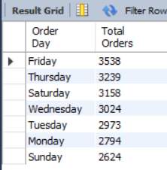**A. Daily Trend for Total Orders**

**SELECT**

**DAYNAME(`order_date`) AS 'Order Day',**

**COUNT(DISTINCT (`order_id`)) AS 'Total Orders'**

**FROM**

**pizza_sales**

**GROUP BY DAYNAME(`order_date`)**

**ORDER BY `Total Orders` DESC;**

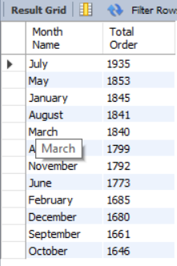

**B. Monthly Trend for Orders**

**SELECT**

**MONTHNAME(`order_date`) AS 'Month Name',**

**COUNT(DISTINCT (`order_id`)) AS "Total Order"**

**FROM**

**pizza_sales**

**GROUP BY MONTHNAME(`order_date`)**

**ORDER BY `Total Order` DESC;**

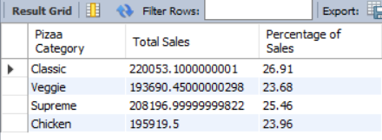**C. % of Sales by Pizza Category**

**SELECT**

**`pizza_category` AS 'Pizaa Category',**

**SUM(`total_price`) AS 'Total Sales',**

**(ROUND(SUM(`total_price`) / (SELECT**

**SUM(`total_price`)**

**FROM**

**pizza_sales),**

**4)) * 100 AS 'Percentage of Sales'**

**FROM**

**pizza_sales**

**GROUP BY pizza_category;**

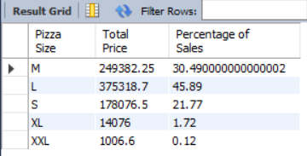**D. % of Sales by Pizza Size**

**SELECT**

**`pizza_size` AS 'Pizza Size',**

**ROUND(SUM((`total_price`)),4) AS 'Total Price',**

**(ROUND(SUM(`total_price`) / (SELECT**

**SUM(`total_price`)**

**FROM**

**pizza_sales),**

**4)) * 100 AS 'Percentage of Sales'**

**FROM**

**pizza_sales**

**GROUP BY `pizza_size`;**

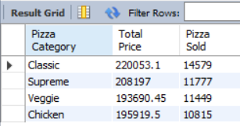**E. Total Pizzas Sold by Pizza Category**

**SELECT**

**`pizza_category` AS 'Pizza Category',**

**ROUND(SUM(`total_price`),3) AS 'Total Price',**

**COUNT(`total_price`) AS 'Pizza Sold'**

**FROM**

**pizza_sales**

**GROUP BY `pizza_category`**

**ORDER BY `Pizza Sold` DESC;**

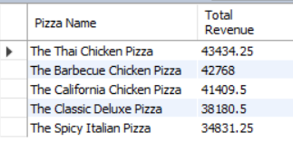**F. Top 5 Pizzas by Revenue**

**SELECT**

**`pizza_name` AS 'Pizza Name',**

**SUM(`total_price`) AS 'Total Revenue'**

**FROM**

**pizza_sales**

**GROUP BY `pizza_name`**

**ORDER BY `Total Revenue` DESC**

**LIMIT 5;**

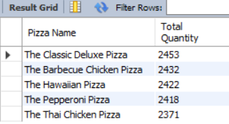**G. Top 5 Pizza by Total Quantity**

**SELECT**

**`pizza_name` AS 'Pizza Name',**

**SUM(`quantity`) AS 'Total Quantity'**

**FROM**

**pizza_sales**

**GROUP BY `pizza_name`**

**ORDER BY `Total Quantity` DESC**

**LIMIT 5;**

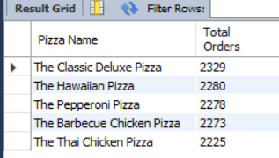**H. Top 5 Pizzas by Total Orders**

**SELECT**

**`pizza_name` AS 'Pizza Name',**

**COUNT(DISTINCT(`order_id`)) AS 'Total Orders'**

**FROM**

**pizza_sales**

**GROUP BY `pizza_name`**

**ORDER BY `Total Orders` DESC**

**LIMIT 5;**